44-560 Advanced Topics in Database Systems

Associative Entities
The ER model discussed in the slides is shown here:
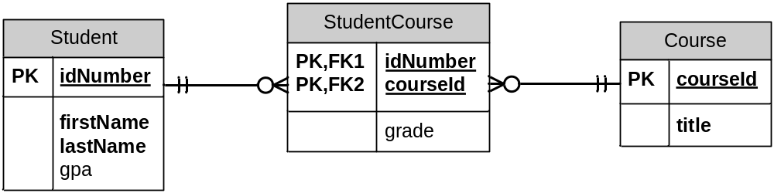

Exercises
- Create some sample data for the tables represented by the entities shown above. Include at least three student records, four course records, and five records in the associative entity.
- Create the ER model shown above, using Visio.
  - First create the model for the two entities Student and Course.
  - Next create the model for StudentCourse.
  - Add the grade attribute. Add the primary key components idNumber and courseId.
  - Create the 1:N relationships between Student and StudentCourse and between Course and StudentCourse.
  - Now select one of the relationship lines. Right-click and turn off the “Set Identifying” option. How does the line appear? Set it back to identifying (as associative entities have identifying relationships). Verify your model looks like the drawing above.
- Create a Visio model for the situation described below.
  - A product is supplied by at least one, and possibly many, vendors.
  - A vendor may supply many products.
  - Some vendors supply no products.
  - For each product, store the product id, product name, and description.
  - For each vendor, store the vendor id, vendor name, and name (first and last) of contact person.
  - For each product supplied by a vendor, store the price the vendor charges for the product.
  - Omit the labels from the relationship lines.
- Show some sample data that might be stored in the database represented by the ER model.

